ExportSmart: Empowering Small Businesses, Facilitating Global Trade

**Empowering Small Exporters with Advanced Trade Compliance and Growth Solutions to Thrive in the Global Marketplace**

Sravani Patwari

07.05.2024

"Success in international trade isn't just about crossing borders; it's about navigating them wisely."

1. Abstract

In an increasingly interconnected global economy, small and medium-sized businesses (SMBs) face significant challenges in navigating the complexities of international trade while ensuring compliance with ever-evolving regulations. To address these challenges, the Trade Compliance Platform for SMBs integrates advanced technologies, including AI and ML, to streamline trade processes and facilitate sustainable growth in the global marketplace. Leveraging AI-driven automation, the platform empowers SMBs to automate trade compliance tasks such as product classification, anomaly detection, and regulatory checks, reducing manual errors and mitigating compliance risks. Additionally, predictive analytics and optimization algorithms enable SMBs to forecast demand, optimise export logistics, and identify potential risks, enhancing operational efficiency and driving strategic decision-making.

With a focus on empowering SMBs, the platform offers personalised solutions tailored to the unique needs and constraints of small exporters. By providing actionable insights and recommendations, SMBs can optimise inventory management, mitigate compliance risks, and capitalise on emerging market opportunities. Furthermore, the integration of AI-powered customer segmentation and targeted marketing enables SMBs to enhance customer engagement and loyalty, driving revenue growth and market expansion. Through the Trade Compliance Platform, SMBs can navigate the complexities of international trade with confidence, unlocking new pathways for success in the global marketplace.

As the global economy continues to evolve, the Trade Compliance Platform remains at the forefront of innovation, empowering SMBs to thrive in an increasingly competitive landscape. By harnessing the power of AI and ML, the platform enables SMBs to overcome traditional barriers to entry and expand their reach in international markets. With a commitment to excellence and continuous improvement, the Trade Compliance Platform stands as a testament to the transformative potential of technology in driving sustainable growth and prosperity for small exporters worldwide.

2. Introduction

In an era characterised by unprecedented globalisation and digital transformation, small and medium-sized businesses (SMBs) play a crucial role in driving economic growth and fostering international trade. However, navigating the complexities of cross-border commerce poses significant challenges for SMBs, particularly in terms of trade compliance and regulatory adherence. As SMBs expand their reach into global markets, they are confronted with a myriad of import/export regulations, tariffs, and sanctions imposed by different countries and trade blocs. Ensuring compliance with these regulations is not only essential for avoiding costly penalties and delays but also for maintaining credibility and competitiveness in the global marketplace.

Against this backdrop, the development of the Trade Compliance Platform for SMBs represents a paradigm shift in how small exporters approach trade compliance and growth strategies. By leveraging cutting-edge technologies such as Artificial Intelligence (AI) and Machine Learning (ML), the platform offers innovative solutions to streamline trade processes, mitigate compliance risks, and unlock new opportunities for expansion. With its user-friendly interface and customizable features, the platform empowers SMBs to navigate the complexities of international trade with confidence, enabling them to focus on core business activities and strategic initiatives.

At its core, the Trade Compliance Platform embodies a commitment to democratising access to global markets and levelling the playing field for small exporters. By providing SMBs with access to advanced tools and insights traditionally reserved for larger enterprises, the platform catalyses growth and fosters innovation within the SMB sector. As the global economy continues to evolve and become increasingly interconnected, the Trade Compliance Platform stands as a beacon of opportunity, empowering SMBs to thrive in the complex and dynamic landscape of international trade.

3. Problem statement

Small and medium-sized businesses (SMBs) engaged in international trade face significant challenges in navigating the complex landscape of trade compliance. With a myriad of import/export regulations, tariffs, and sanctions imposed by different countries and trade blocs, SMBs often struggle to ensure compliance while managing limited resources and expertise. Manual processes for trade compliance are time-consuming, error-prone, and costly, leading to potential delays in shipments, penalties, and reputational damage. Moreover, the lack of access to advanced technologies exacerbates these challenges, hindering SMBs' ability to compete effectively in the global marketplace. As SMBs seek to expand their reach and capitalise on international trade opportunities, there is an urgent need for innovative solutions that streamline trade compliance processes, mitigate risks, and facilitate sustainable growth.

4.Market Need Assessment

The market for trade compliance solutions for small and medium-sized businesses (SMBs) is characterised by a growing demand for streamlined and cost-effective solutions to navigate the complexities of international trade regulations. SMBs engaged in cross-border commerce face mounting pressure to ensure compliance with import/export regulations, tariffs, and sanctions while managing limited resources and expertise. With globalisation opening up new opportunities for market expansion, SMBs are increasingly seeking solutions that automate trade compliance processes, reduce manual errors, and mitigate compliance risks. Moreover, the proliferation of e-commerce and digital platforms has intensified the need for scalable and user-friendly solutions that cater to SMBs' diverse needs and operational constraints. Against this backdrop, there is a clear market demand for a comprehensive Trade Compliance Platform tailored specifically to the needs of SMBs, offering advanced features, customization options, and affordability to support their growth and competitiveness in the global marketplace.

**How AI Can Automate Processes in Export Compliance**

AI has emerged as a game-changer in the realm of export compliance.[3](https://www.linkedin.com/pulse/how-ai-lei-transforming-compliance-trade-finance-dr-ari-aaltonen/) The technology can analyse vast amounts of data and recognize patterns. They can even make informed decisions that align perfectly with the multifaceted demands of compliance procedures.

• Automating Classification and Screening

One of the core challenges in export compliance is accurately classifying products and technologies to determine their level of export control. AI-powered tools equipped with natural language processing (NLP) capabilities.

NLP can interpret product descriptions, technical specifications, and other relevant documents to provide accurate classification recommendations.4 This eliminates manual errors and accelerates the process, allowing businesses to make informed decisions swiftly.

Additionally, AI is vital in screening individuals, entities, and organisations against various sanctions and watchlists. It can automatically cross-reference trade partners against global databases. As such, AI systems can flag potential red flags, ensuring that businesses don’t inadvertently engage with prohibited parties.

• Dynamic Licensing and Documentation

Export licences are a critical component of compliance. They authorise businesses to export controlled items. The application process for export licences can be intricate. It usually involves submitting extensive documentation detailing the nature of the export, end-use, and recipient country.

AI-driven solutions can aid businesses in understanding the specific requirements for different types of licenses.2 The technology can generate accurate documentation and even suggest optimal licensing strategies based on historical data and regulatory changes.

• Real-Time Risk Assessment

Regulatory changes can occur suddenly, especially in the global trade industry. It can impact the compliance status of specific products or destinations. AI algorithms can monitor real-time regulatory updates, analyse their potential impact on existing trade activities, and alert businesses to necessary adjustments.

This proactive approach helps companies to stay ahead of compliance changes and make informed decisions swiftly, minimising disruptions and penalties.

• Enhancing Due Diligence

Before engaging in trade with a new partner, conducting due diligence is crucial to ensure their legitimacy and compliance adherence. AI-driven algorithms can analyse a partner’s financial stability, reputation, and past compliance history to provide a comprehensive risk assessment.5 This expedites the due diligence process and reduces the chances of partnering with entities that may expose the business to compliance risks.

•Data Analytics for Compliance Trends

AI can process large volumes of data to identify compliance trends, patterns, and potential risk areas.6 This insight helps businesses proactively adjust their strategies and procedures. Data analytics is vital in uncovering weaknesses and ensuring companies are up-to-date with the latest export compliance regulations. 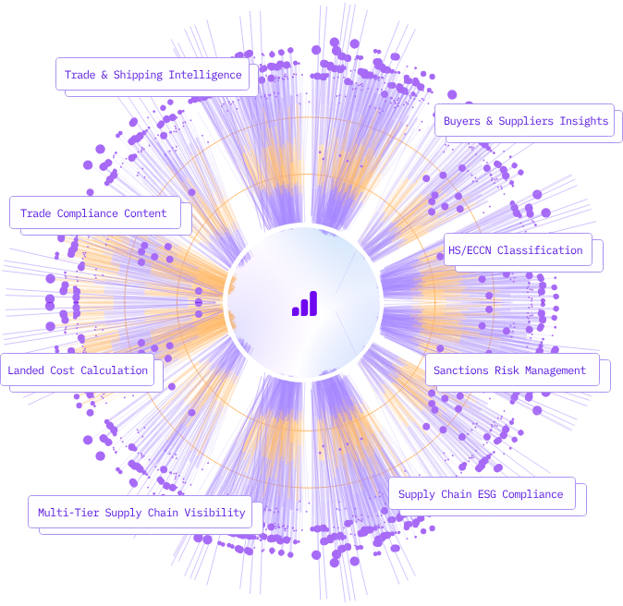

5. Target Specifications

The Trade Compliance Platform is specifically designed to address the pain points faced by small and medium-sized exporters by offering a comprehensive solution that simplifies trade compliance processes. Leveraging advanced AI and machine learning technologies, the platform automates tedious manual tasks, such as classification of goods and screening for restricted parties, reducing the risk of errors and ensuring adherence to import/export regulations.

Small and medium-sized exporters often lack the resources and expertise to navigate complex trade regulations effectively. The platform provides these businesses with access to sophisticated compliance tools previously available only to large enterprises, levelling the playing field and enabling them to compete in the global market.

By offering features such as automated classification of goods based on Harmonized System (HS) codes, dynamic updates on changes to import/export regulations and tariffs, and integration with shipping and logistics providers, the platform streamlines compliance processes and facilitates smooth cross-border trade operations.

With a user-friendly interface and seamless integration with existing systems, the Trade Compliance Platform empowers exporters to focus on growing their businesses while ensuring compliance with international trade regulations. Whether they are manufacturers, distributors, or e-commerce sellers, exporters of all sizes can benefit from the platform's capabilities, enabling them to expand their global reach and drive business growth.

6. External Search

Research on international trade regulations, tariffs, and sanctions imposed by different countries and trade blocs.

Analysis of existing trade compliance software solutions and platforms.

Case studies and success stories of small exporters facing trade compliance challenges.

<https://www.planetcompliance.com/export-compliance-artificial-intelligence/>

<https://www.trademo.com/>

**What are the Challenges and Future Directions of AI for Export Compliance?**

While AI holds immense promise for automating export compliance, some challenges must be addressed. These include:

* Ensuring the accuracy and reliability of AI algorithms
* Data privacy concerns
* Need for human oversight

Striking the right balance between automation and human intervention will be key to successfully integrating AI in export compliance.

Looking ahead, the future of AI in export compliance is promising. As technology evolves, AI systems are more likely to become more sophisticated. It can handle even complex compliance scenarios with minimal human intervention.

7. Benchmarking products

Existing trade compliance platforms offer features such as automated classification of goods, screening for restricted parties, and generating export documentation. However, many solutions are designed for large enterprises and may not be suitable for the needs and budgets of small exporters.

8. Applicable Regulations

* Addresses import/export regulations: The Trade Compliance Platform for Small Exporters ensures compliance with the diverse and often intricate import/export regulations imposed by countries of origin and destination. This includes navigating requirements related to documentation, customs procedures, and product classifications.
* Ensures adherence to tariffs and trade agreements: The platform facilitates compliance with tariffs and trade agreements such as NAFTA (North American Free Trade Agreement), WTO (World Trade Organization) agreements, and others. It assists SMBs in understanding and applying the applicable tariff rates and preferential trade terms to their exports.
* Assists in navigating sanctions regulations: The Trade Compliance Platform also aids SMBs in navigating sanctions regulations enforced by international bodies like the UN (United Nations) and individual countries. It helps identify restricted parties, entities, and sanctioned countries to prevent inadvertent violations and minimise the risk of penalties.
* Minimises the risk of non-compliance and associated penalties: By ensuring adherence to import/export regulations, tariffs, and sanctions, the platform minimises the risk of non-compliance for SMBs. This helps mitigate potential penalties, delays in shipments, and reputational damage, thereby safeguarding the interests of small exporters in the global marketplace.

9. Applicable Constraints

* Budget constraints pose challenges for small exporters: Small exporters often operate within limited budgets, necessitating cost-effective solutions for trade compliance. The Trade Compliance Platform offers affordable options tailored to the financial constraints of SMBs, ensuring accessibility without compromising on functionality or effectiveness.
* Necessitates cost-effective solutions: Recognizing the financial constraints faced by SMBs, the platform focuses on delivering value-driven solutions that offer tangible benefits at reasonable costs. This includes providing scalable pricing models, flexible payment options, and transparent pricing structures to accommodate varying budgetary needs.
* Recognizes limited expertise in trade compliance among SMBs: Many SMBs lack the specialised knowledge and expertise required to navigate complex trade regulations effectively. The Trade Compliance Platform addresses this challenge by offering user-friendly interfaces, intuitive workflows, and educational resources to empower SMBs with the knowledge and tools needed for compliance.
* Offers user-friendly interfaces tailored to SMBs' needs: Usability is a key consideration for SMBs when adopting new technology solutions. The Trade Compliance Platform prioritises user experience, offering intuitive interfaces, guided workflows, and personalised support to ensure ease of use and adoption for SMBs with varying levels of technical proficiency.
* Enhances usability through seamless integration with existing systems: Integration with existing systems is essential for SMBs to streamline their operations and maximise efficiency. The Trade Compliance Platform offers seamless integration capabilities, allowing SMBs to integrate compliance processes with their existing ERP (Enterprise Resource Planning), CRM (Customer Relationship Management), and logistics systems for enhanced productivity and workflow automation.

**Business Opportunity:**

* Growing demand for streamlined trade compliance solutions for small exporters in the increasingly complex global marketplace.
* Opportunity to develop a comprehensive Trade Compliance Platform tailored to the unique needs and constraints of SMBs.
* Potential to leverage AI and machine learning technologies to enhance platform capabilities, offering predictive analytics, optimization algorithms, and personalised insights.
* Opportunity to provide additional value-added services such as training, education, and networking opportunities to support SMBs in their export endeavours.
* Potential to establish long-lasting relationships with SMBs and position oneself as a trusted partner in international trade, leading to a profitable and sustainable business venture.

**Business Monetization Idea:**

Imagine a world where small exporters can effortlessly navigate the complexities of international trade compliance while staying within their budget. That's precisely what the Trade Compliance Platform for Small Exporters aims to achieve with its innovative monetization strategy. Picture this: a subscription-based model that scales with your business, offering essential compliance features at an affordable price. But wait, there's more! For those seeking an extra edge, premium features like real-time compliance updates, expert consulting services, and seamless ERP integration are just a click away, available for an additional fee. It's like having a team of compliance experts at your fingertips, guiding you every step of the way.

But that's not all – the Trade Compliance Platform doesn't believe in one-size-fits-all solutions. That's why we offer a freemium model, giving you access to basic compliance features for free. It's our way of saying, "Try it out, see the difference it makes, and when you're ready for more, we'll be here." We understand that every business is unique, with its own set of challenges and aspirations. That's why we've crafted a range of pricing options and value propositions to suit your needs – because your success is our success.

So, whether you're a seasoned exporter or just dipping your toes into international trade, the Trade Compliance Platform is your partner in navigating the global marketplace. With our innovative monetization strategy, we're not just helping you comply with regulations – we're helping you thrive. Because when SMBs succeed, economies flourish, and that's a win-win for everyone.

Concept Generation and Development:

The concept of the Trade Compliance Platform originated from the recognition of the challenges faced by small exporters in navigating complex trade compliance requirements. Leveraging the potential of AI and machine learning, the platform streamlines processes and reduces compliance risks. Developed as a cloud-based software solution, it automates tasks such as goods classification, screening for restricted parties, and generating export documentation. Dynamic updates on regulatory changes and seamless integration with shipping and logistics providers ensure efficient coordination of export activities, empowering SMBs to navigate international trade with confidence.

Final product prototype:- (Simple schematic diagram)

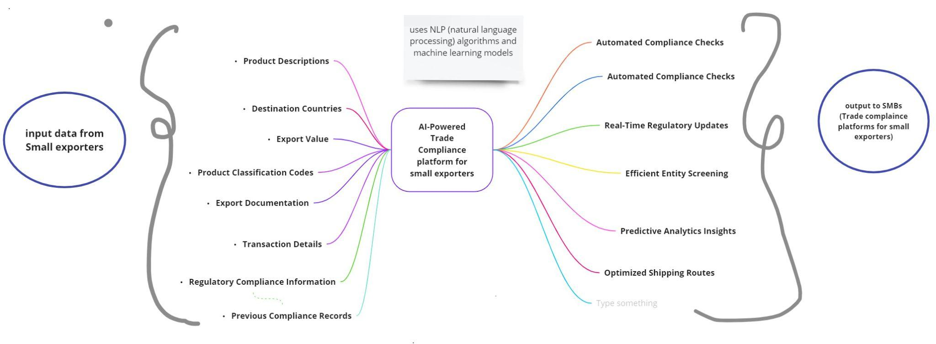

The schematic diagram illustrates the digital workflow of the Trade Compliance Platform, showcasing how AI and ML technologies streamline compliance processes for SMBs engaged in international trade. From input data to compliance checks and export documentation generation, the platform ensures accuracy, efficiency, and regulatory compliance at every step of the export process.

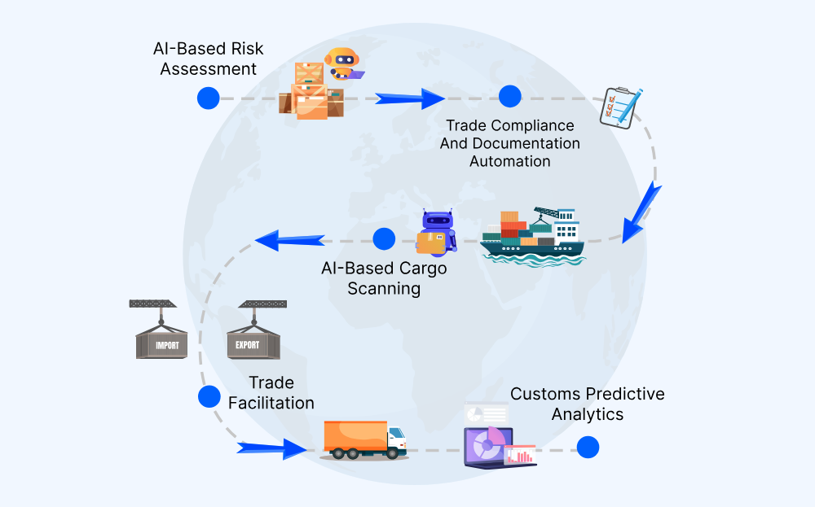

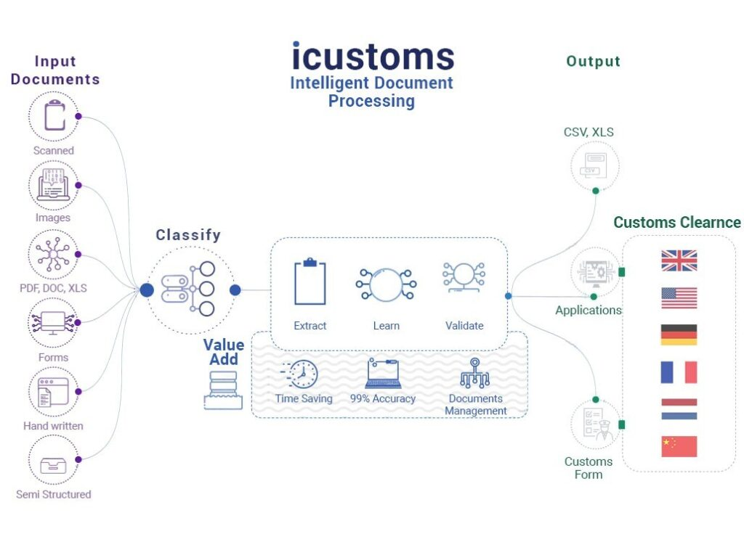

**PRODUCT DETAILS:**

Functionality:

The platform simplifies the complexities of trade compliance by seamlessly ingesting data from SMBs and processing it through advanced AI algorithms. Through this process, actionable insights and export documentation are generated in a flash, empowering SMBs with the knowledge and tools needed to navigate the global marketplace with confidence. With access to a wealth of data sources, including regulatory databases and shipping APIs, SMBs are kept informed and empowered at every stage of the export process.

Data Sources:

* Export Transaction Data: Provided by SMBs, this data serves as the foundation for compliance checks and documentation generation, ensuring that exported goods adhere to regulatory requirements.
* Regulatory Databases: These databases contain detailed information on import/export regulations, tariffs, and sanctions lists, allowing the platform to stay updated on the latest regulatory changes and ensure compliance.
* Real-Time Updates: Obtained from regulatory agencies and international trade organisations, these updates provide timely information on changes to regulations, tariffs, and sanctions, enabling SMBs to adapt their export strategies accordingly and maintain compliance.

Development Team:

Turning this vision into reality requires a dedicated team of professionals – data scientists, software developers, compliance experts, UI/UX designers, and project managers. Together, they collaborate to ensure that our platform meets the highest standards of functionality, usability, and reliability. Their expertise and dedication are instrumental in bringing our prototype to life and empowering SMBs worldwide to thrive in the global marketplace.

Cost and Value Proposition:

While the journey to compliance may seem daunting, the benefits far outweigh the costs. Our platform offers SMBs peace of mind, knowing that their business is compliant and ready to conquer the world. The investment in our solution is a small price to pay for the invaluable support and guidance it provides, ensuring that SMBs can navigate the complexities of international trade with ease and confidence.

Algorithms, Frameworks, Software, etc. Needed:

* Natural Language Processing (NLP) Algorithms: These algorithms are crucial for text classification, enabling the platform to automatically categorise goods based on their descriptions provided by SMBs.
* Machine Learning Models: These models are utilised for entity screening and compliance checks, ensuring that exported goods and involved parties comply with import/export regulations and sanctions.
* Cloud-Based Infrastructure: A robust cloud-based infrastructure is essential for scalability and accessibility, allowing the platform to handle varying levels of data volume and user traffic effectively.
* Integration with Shipping and Logistics APIs: Seamless integration with shipping and logistics APIs facilitates data exchange, enabling SMBs to coordinate export activities efficiently and optimise shipping routes.

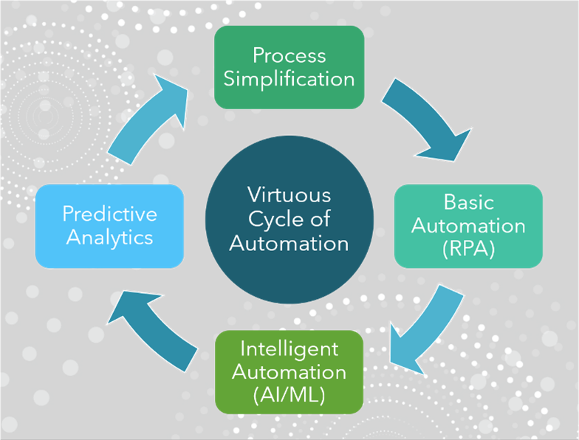

15. Conclusion

Integrating AI into export compliance processes means welcoming a new era of efficiency, accuracy, and automation. Businesses no longer have to navigate the intricate maze of regulations manually. Instead, they can rely on AI-driven solutions to streamline compliance procedures, minimise errors, and adapt swiftly to regulatory changes.

As AI advances, global trade is poised to advance as well. We can expect global trade to become more compliant, efficient, and resilient in the face of ever-changing regulatory landscapes.

**References**

Mlambo C. “The Impact of Port Performance on Trade: The Case of Selected African States.” Economies 2021.

Meltzer J. “The impact of artificial intelligence on international trade.” The Brookings Institution, 2018.

Aaltonen A. “How AI and LEI are Transforming Compliance in Trade Finance Ecosystems.” LinkedIn, 2023.

Gruetzemacher R. “The Power of Natural Language Processing.” Harvard Business Review, 2022.

Smith A. “Using Artificial Intelligence and Algorithms.” Federal Trade Commission, 2020.

Boultwood, B.; “How Artificial Intelligence Will Change Qualitative Risk Assessment,” Global Association of Risk Professionals, 2020.